Khang Nguyen 300007277

Pascal Marleau-Proulx 300034507

## Q1.1

(voir les PDF attacher)

## Q1.2

actionPerformed

|  |  |  |  |
| --- | --- | --- | --- |
| **Numéro de cas de test** | **Données de test incluant les résultats escomptés** | **Branches Couvertes** | **Conditions Couvertes** |
| 1.1 | e.getSource() = buttons[0]  **SE = “1”** | (126-129)-131-132-133-136-137-138-139-196-207-218-229-240-251-261-266 | e.getSource() = buttons[0], clearscreen = true, |
| 1.2 | e.getSource() = buttons[1]  **SE = “2”** | (126-129)-131-136-142-143-144-196-207-218-229-240-251-261-266 | e.getSource() = buttons[1], clearscreen = false |
| 1.3 | e.getSource() = buttons[2]  **SE = “3”** | (126-129)-131-136-142-147-148-149-196-207-218-229-240-251-261-266 | e.getSource() = buttons[2], clearscreen = false |
| 1.4 | e.getSource() = buttons[5]  **SE = “4”** | (126-129)-131-136-142-147-152-153-154-196-207-218-229-240-251-261-266 | e.getSource() = buttons[5], clearscreen = false |
| 1.5 | e.getSource() = buttons[6]  **SE = “5”** | (126-129)-131-136-142-147-152-157-158-159-196-207-218-229-240-251-261-266 | e.getSource() = buttons[6], clearscreen = false |
| 1.6 | e.getSource() = buttons[7]  **SE = “6”** | (126-129)-131-136-142-147-152-157-162-163-164-196-207-218-229-240-251-261-266 | e.getSource() = buttons[7], clearscreen = false |
| 1.7 | e.getSource() = buttons[10]  **SE = “7”** | (126-129)-131-136-142-147-152-157-162-167-168-169-196-207-218-229-240-251-261-266 | e.getSource() = buttons[10], clearscreen = false |
| 1.8 | e.getSource() = buttons[11]  **SE = “8”** | (126-129)-131-136-142-147-152-157-162-167-172-173-174-196-207-218-229-240-251-261-266 | e.getSource() = buttons[11], clearscreen = false |
| 1.9 | e.getSource() = buttons[12]  **SE = “9”** | (126-129)-131-136-142-147-152-157-162-167-172-177-178-179-196-207-218-229-240-251-261-266 | e.getSource() = buttons[12], clearscreen = false |
| 1.10 | e.getSource() = buttons[16]  **SE = “0”** | (126-129)-131-136-142-147-152-157-162-167-172-177-182-183-184-196-207-218-229-240-251-261-266 | e.getSource() = buttons[16], clearscreen = false |
| 1.11 | e.getSource() = buttons[17]  **SE = “0.0”** | (126-129)-131-136-142-147-152-157-162-167-172-177-182-186-187-188-189-190-196-207-218-229-240-251-261-266 | e.getSource() = buttons[17], clearscreen = false,  decnumber = false |
| 1.12 | e.getSource() = buttons[17]  **SE = “0.0”** | (126-129)-131-136-142-147-152-157-162-167-172-177-182-186-187-196-207-218-229-240-251-261-266 | e.getSource() = buttons[17], clearscreen = false,  decnumber = true |
| 1.13 | e.getSource() = buttons[20]  **SE = ArrayIndexOutOfBoundsException** | (126-129)-131-136-142-147-152-157-162-167-172-177-182-186-196-207-218-229-240-251-261-266 | e.getSource() != buttons[i] lorsque 0<= i <= 17, clearscreen = false |
| 1.14 | e.getSource() = buttons[14]  **SE = “”** | (126-129)-196-207-218-229-240-251-252-253-254-255-256-257-261-266 | e.getSource() = buttons[14], doubleclick = true |
| 1.15 | e.getSource() = buttons[14], input = “5”  **SE = “2.23606797749979”** | (126-129)-196-207-218-229-240-251-252-253-254-255-257-261-266 | e.getSource() = buttons[14], doubleclick = false |
| 1.16 | e.getSource() = buttons[13]  **SE = “”** | (126-129)-196-207-218-229-240-241-242-243-244-245-246-247-261-266 | e.getSource() = buttons[13], doubleclick = true |
| 1.17 | e.getSource() = buttons[13], input = “6”  **SE = “6”** | (126-129)-196-207-218-229-240-241-242-243-244-245-247-261-266 | e.getSource() = buttons[13], doubleclick = false |
| 1.18 | e.getSource() = buttons[15], input = “1”  **SE = “0”** | (126-129)-196-207-218-229-240-251-261-262-266 | e.getSource() = buttons[15] |
| 1.19 | e.getSource() = buttons[18]  **SE = “”** | (126-129)-196-207-218-229-240-251-261-266-267-268-269-270-271-272 | e.getSource() = buttons[18], doubleclick = true |
| 1.20 | e.getSource() = buttons[18], input = “3”  **SE = “3”** | (126-129)-196-207-218-229-240-251-261-266-267-268-269-270-272 | e.getSource() = buttons[18], Doubleclick = false |
| 1.21 | e.getSource() = buttons[9]  **SE = “”** | (126-129)-196-207-218-229-230-231-232-233-234-235-236-261-266 | e.getSource() = buttons[9], doubleclick = true |
| 1.22 | e.getSource() = buttons[9], input = “4”  **SE = “4”** | (126-129)-196-207-218-229-230-231-232-233-234-236-261-266 | e.getSource() = buttons[9], doubleclick = false |
| 1.23 | e.getSource() = buttons[8]  **SE = “”** | (126-129)-196-207-218-219-220-221-222-223-224-225-261-266 | e.getSource() = buttons[8], doubleclick = true |
| 1.24 | e.getSource() = buttons[8], input = “2”  **SE = “2”** | (126-129)-196-207-218-219-220-221-222-223-225-261-266 | e.getSource() = buttons[8], doubleclick = false |
| 1.25 | e.getSource() = buttons[4]  **SE = “”** | (126-129)-196-207-208-209-210-211-212-213-214-261-266 | e.getSource() = buttons[4], doubleclick = true |
| 1.26 | e.getSource() = buttons[4], input = “6”  **SE = “6”** | (126-129)-196-207-208-209-210-211-212-214-261-266 | e.getSource() = buttons[4], doubleclick = false |
| 1.27 | e.getSource() = buttons[3]  **SE = “”** | (126-129)-196-197-198-199-200-201-202-203-261-266 | e.getSource() = buttons[3], doubleclick = true |
| 1.28 | e.getSource() = buttons[3], input = “7”  **SE = “7”** | (126-129)-196-197-198-199-200-201-203-261-266 | e.getSource() = buttons[3], doubleclick = false |

processNumber

|  |  |  |  |
| --- | --- | --- | --- |
| **Numéro de cas de test** | **Données de test incluant les résultats escomptés** | **Branches Couvertes** | **Conditions Couvertes** |
| 2.1 | e.getSource() = buttons[18], input = “3”  **ES = “3”** | 284-286-287-288-293-296-297-298-299-301 | firstpress = true, equals = true |
| 2.2 | e.getSource() = buttons[14], input = “4”  **ES = “2.0”** | 284-286-291-301 | firstpress = true, equals = false, oper = SQRT, |
| 2.3 | e.getSource() = buttons[18], input = “4”, oper = ADD, num1 = 3  **ES = “7.0”** | 284-306-323-325-326-327-328-332-333-334-336 | firstpress = false, !morenums = false, equals = true |
| 2.4 | e.getSource() = buttons[9], input = “2”, newoper = DIVI, num1 = 9, num2 = 3, oldoper = ADD  **ES = “6.0”** | 284-306-323-325-332-333-334-336 | firstpress = false, !morenums = false, equals = false |
| 2.5 | e.getSource() = buttons[4], input = “4”, num1 = 6, oldoper = MULT  **ES = “24.0”** | 284-306-308-309-310-311-313-316-317 | firstpress = false, !morenums = true, !equals = false |
| 2.6 | e.getSource() = buttons[18], num1 = 7, num2 = 8, input = “9”, oldoper = ADD, newoper = MULT  **ES = “135.0”** | 284-306-308-309-310-311-313-314 | firstpress = false, !morenums = true, !equals = true |

Calculate

|  |  |  |  |
| --- | --- | --- | --- |
| **Numéro de cas de test** | **Données de test incluant les résultats escomptés** | **Branches Couvertes** | **Conditions Couvertes** |
| 3.1 | number1 = 12, number2 = 32,  oper = ADD  **ES = “44.0”** | 346-350-369 | ADD = T, SUB = F, MULT = F, DIVI = F, POW = F, SQRT = F |
| 3.2 | number1 = 45, number2 = 23,  oper = SUB  **ES = “22.0”** | 346-353-369 | ADD = F, SUB = T, MULT = F, DIVI = F, POW = F, SQRT = F |
| 3.3 | number1 = 2, number2 = 54,  oper = MULT  **ES = “108.0”** | 346-356-369 | ADD = F, SUB = F, MULT = T, DIVI = F, POW = F, SQRT = F |
| 3.4 | number1 = 24, number2 = 43,  oper = DIVI  **ES = “0.5581395348837209”** | 346-359-369 | ADD = F, SUB = F, MULT = F, DIVI = T, POW = F, SQRT = F |
| 3.5 | number1 = 654, number2 = 3,  oper = POW  **ES = “2.79726264E8”** | 346-362-369 | ADD = F, SUB = F, MULT = F, DIVI = F, POW = T, SQRT = F |
| 3.6 | number1 = 43,  oper = SQRT  **ES = “6.557438524302”** | 346-365-369 | ADD = F, SUB = F, MULT = F, DIVI = F, POW = F, SQRT = T |
| 3.7 | Number1 = 3, number2 = 23,  oper = KHANG = 10  **ES = “0.0”** | 346-369 | ADD = F, SUB = F, MULT = F, DIVI = F, POW = F, SQRT = F |

## Question 1.3

Voir projet attacher

## Question 1.4

Nous avons toucher 100% des instructions (pour actionPerfmored, processNumbers et calculate), mais pas 100% pour tous le code comme ils avait des méthodes que nous n’avions pas besoins de tester. Cependant Nous n’avons pas frapper tous les conditions de chaque if statement. Il n’est pas 100% parce que la ligne 186 (qui check si le bouton est 17) ne peut pas être faux parce que si le bouton est 3, 4, 8, 9, 13, 14, 15, ou 18, il va skipper au ligne 196, si le bouton est 0, 1, 2, 3, 5, 6, 7, 10, 11, 12, 16 ou 17, il va être vrais avant ou sur ligne 186, le seule façon d’avoir fausse sur la ligne 186 est d’avoir un bouton plus petit que 0 ou plus grand que 18, mais cela nous donne un erreur IndexOutOfBoundsException. De plus, la ligne 323 doit être vrais parce que la ligne 306 check si morenums est faux, et la ligne 323 (qui check si morenums est vrais) peut seulement être accéder si morenums est vrais, et parce que morenums est vrais pour acceder la ligne 323, la ligne 323 vas toujour etre vrais.

calCFrame

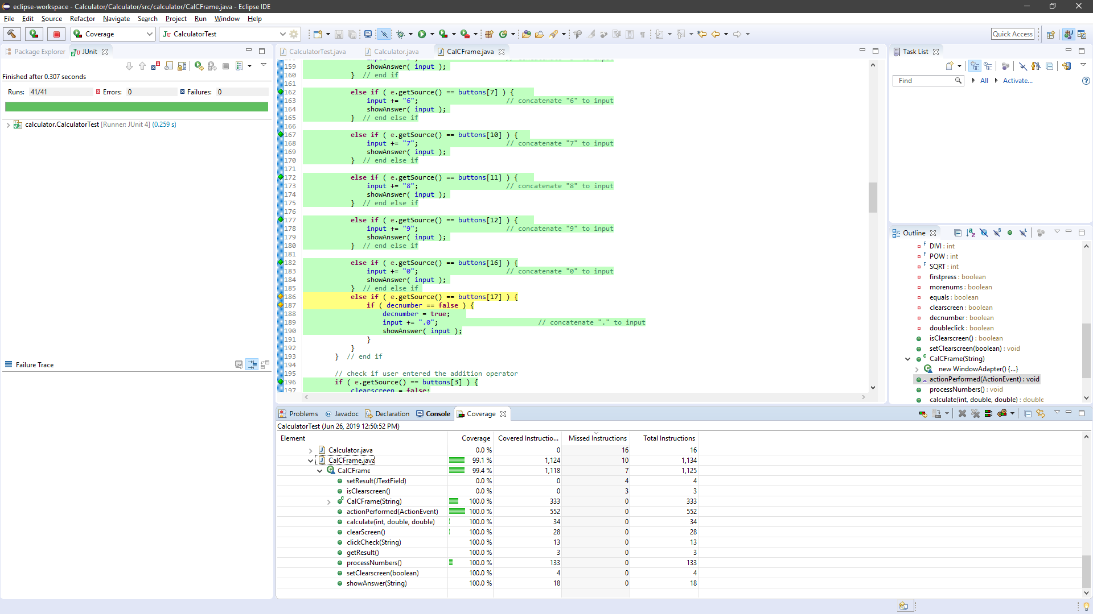

CalculatorTest (rouge pour IndexOutOfBoundsException)

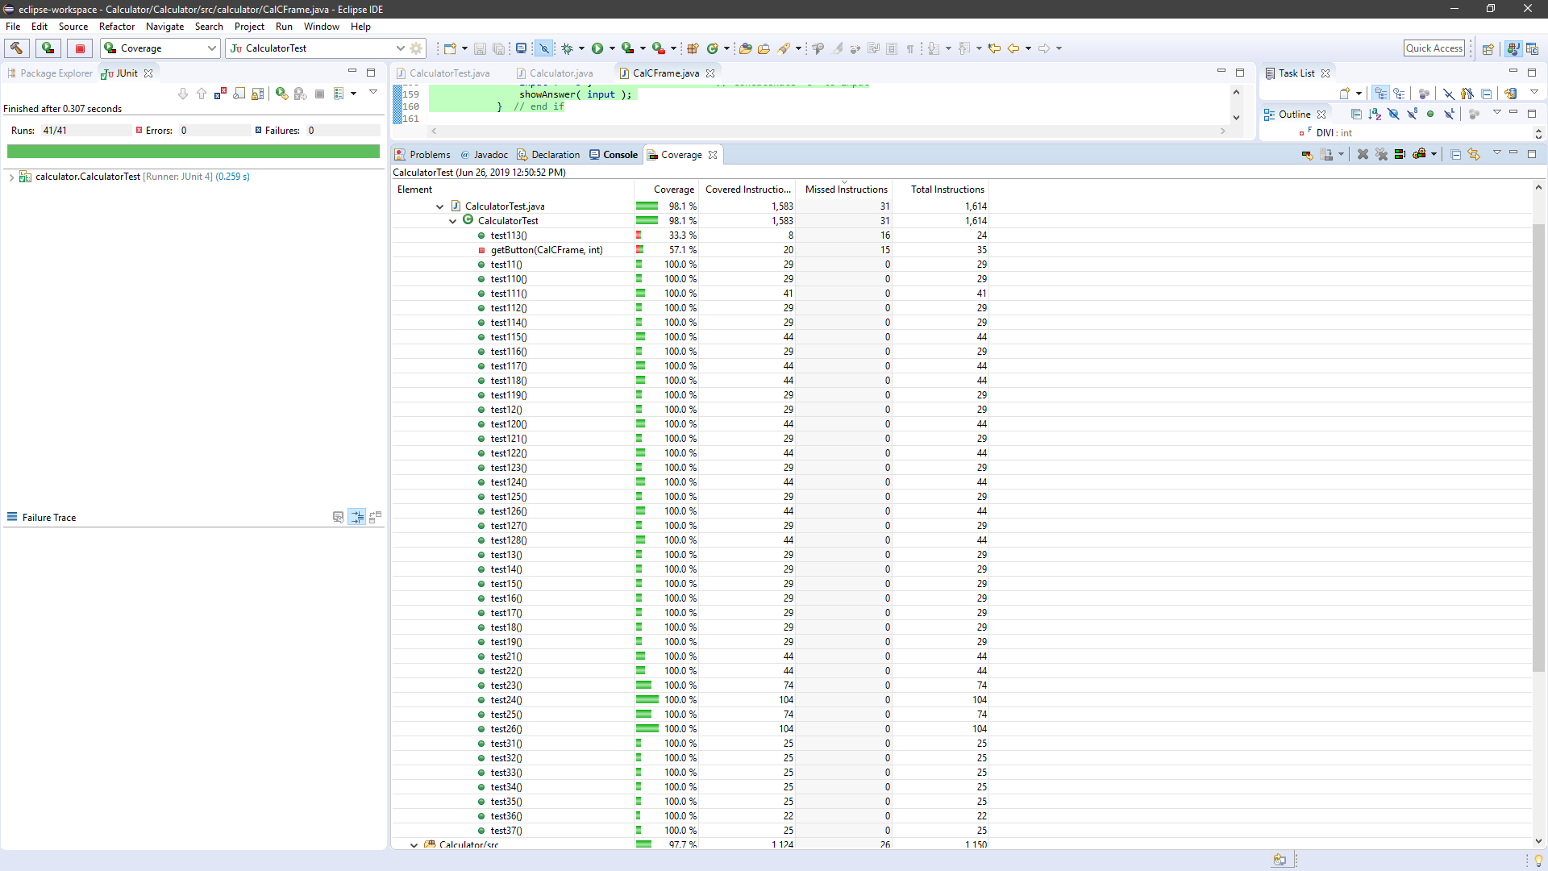

Partie 2 - **Question 2.1 (20%)**

: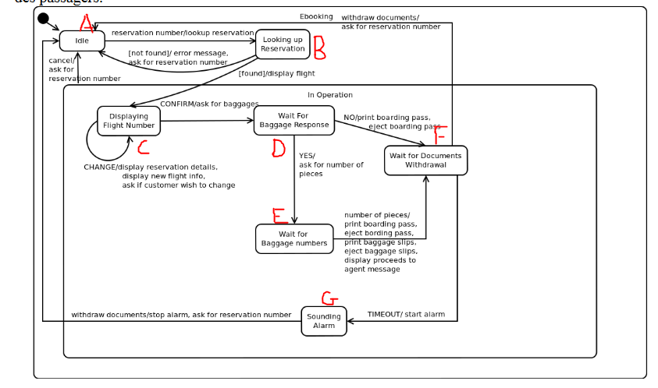

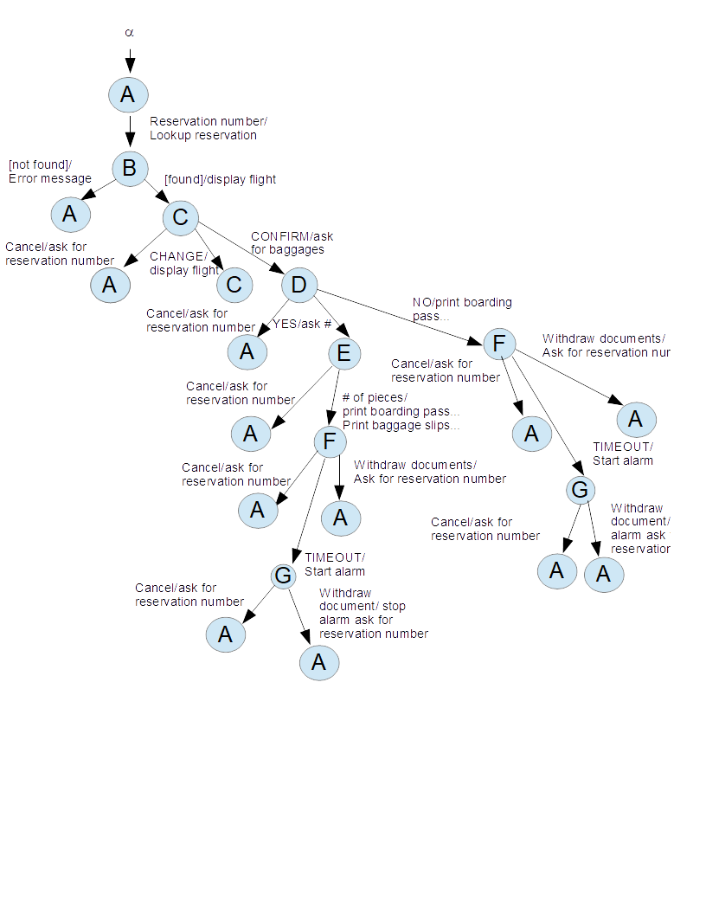

**Question 2.2 (10%)**

**Test de conformité**

|  |  |  |  |  |  |
| --- | --- | --- | --- | --- | --- |
| **ID** | **Etat initial** | **Evenement** | **Condition** | **Reaction** | **Etat resultat** |
| **1.1** | **α** | **constructor** | **-** | **-** | **A** |
| **1.2** | **A** | **Reservation number** | **-** | **Lookup reservation** | **B** |
| **1.3** | **B** | **-** | **[not found]** | **Error message**  **Ask for reservation number** | **A** |
| **2.1** | **α** | **constructor** | **-** | **-** | **A** |
| **2.2** | **A** | **Reservation number** | **-** | **Lookup reservation** | **B** |
| **2.3** | **B** | **-** | **[found]** | **Display flight** | **C** |
| **2.4** | **C** | **Cancel** | **-** | **Ask for reservation number** | **A** |
| **3.1** | **α** | **constructor** | **-** | **-** | **A** |
| **3.2** | **A** | **Reservation number** | **-** | **Lookup reservation** | **B** |
| **3.3** | **B** | **-** | **[found]** | **Display flight** | **C** |
| **3.4** | **C** | **Change** | **-** | **Display reservation details, display new flight info, ask if customer wish to change** | **C** |
| **4.1** | **α** | **constructor** | **-** | **-** | **A** |
| **4.2** | **A** | **Reservation number** | **-** | **Lookup reservation** | **B** |
| **4.3** | **B** | **-** | **[found]** | **Display flight** | **C** |
| **4.4** | **C** | **Confirm** | **-** | **Ask for baggages** | **D** |
| **4.5** | **D** | **Cancel** | **-** | **Ask for reservation number** | **A** |
| **5.1** | **α** | **constructor** | **-** | **-** | **A** |
| **5.2** | **A** | **Reservation number** | **-** | **Lookup reservation** | **B** |
| **5.3** | **B** | **-** | **[found]** | **Display flight** | **C** |
| **5.4** | **C** | **Confirm** | **-** | **Ask for baggages** | **D** |
| **5.5** | **D** | **Yes** | **-** | **Ask for number of pieces** | **E** |
| **5.6** | **E** | **Cancel** | **-** | **Ask for reservation number** | **A** |
| **6.1** | **α** | **constructor** | **-** | **-** | **A** |
| **6.2** | **A** | **Reservation number** | **-** | **Lookup reservation** | **B** |
| **6.3** | **B** | **-** | **[found]** | **Display flight** | **C** |
| **6.4** | **C** | **Confirm** | **-** | **Ask for baggages** | **D** |
| **6.5** | **D** | **Yes** | **-** | **Ask for number of pieces** | **E** |
| **6.6** | **E** | **Number of pieces** |  | Print boarding pass, eject boarding pass, print baggage slips, eject baggage slips, agent message | **F** |
| **6.7** | **F** | **Cancel** | **-** | **Ask for reservation number** | **A** |
| **7.1** | **α** | **constructor** | **-** | **-** | **A** |
| **7.2** | **A** | **Reservation number** | **-** | **Lookup reservation** | **B** |
| **7.3** | **B** | **-** | **[found]** | **Display flight** | **C** |
| **7.4** | **C** | **Confirm** | **-** | **Ask for baggages** | **D** |
| **7.5** | **D** | **Yes** | **-** | **Ask for number of pieces** | **E** |
| **7.6** | **E** | **Number of pieces** | **-** | Print boarding pass, eject boarding pass, print baggage slips, eject baggage slips, agent message | **F** |
| **7.7** | **F** | **Withdraw documents** | **--** | **Ask for reservation number** | **A** |
| **8.1** | **α** | **constructor** | **-** | **-** | **A** |
| **8.2** | **A** | **Reservation number** | **-** | **Lookup reservation** | **B** |
| **8.3** | **B** | **-** | **[found]** | **Display flight** | **C** |
| **8.4** | **C** | **Confirm** | **-** | **Ask for baggages** | **D** |
| **8.5** | **D** | **Yes** | **-** | **Ask for number of pieces** | **E** |
| **8.6** | **E** | **Number of pieces** |  | Print boarding pass, eject boarding pass, print baggage slips, eject baggage slips, agent message | **F** |
| **8.7** | **F** | **TIMEOUT** | **--** | **Start alarm** | **G** |
| **8.8** | **G** | **Cancel** | **-** | **Ask for reservation number** | **A** |
| **9.1** | **α** | **constructor** | **-** | **-** | **A** |
| **9.2** | **A** | **Reservation number** | **-** | **Lookup reservation** | **B** |
| **9.3** | **B** | **-** | **[found]** | **Display flight** | **C** |
| **9.4** | **C** | **Confirm** | **-** | **Ask for baggages** | **D** |
| **9.5** | **D** | **Yes** | **-** | **Ask for number of pieces** | **E** |
| **9.6** | **E** | **Number of pieces** |  | Print boarding pass, eject boarding pass, print baggage slips, eject baggage slips, agent message | **F** |
| **9.7** | **F** | **TIMEOUT** | **--** | **Start alarm** | **G** |
| **9.8** | **G** | **Withdraw document** | **-** | **Stop alarm. Ask for reservation number** | **A** |
| **10.1** | **α** | **constructor** | **-** | **-** | **A** |
| **10.2** | **A** | **Reservation number** | **-** | **Lookup reservation** | **B** |
| **10.3** | **B** | **-** | **[found]** | **Display flight** | **C** |
| **10.4** | **C** | **Confirm** | **-** | **Ask for baggages** | **D** |
| **10.5** | **D** | **NO** | **-** | **Print boarding pass, eject boarding pass** | **F** |
| **10.6** | **F** | **Cancel** | **-** | Ask for reservation number | **A** |
| **11.1** | **α** | **constructor** | **-** | **-** | **A** |
| **11.2** | **A** | **Reservation number** | **-** | **Lookup reservation** | **B** |
| **11.3** | **B** | **-** | **[found]** | **Display flight** | **C** |
| **11.4** | **C** | **Confirm** | **-** | **Ask for baggages** | **D** |
| **11.5** | **D** | **NO** | **-** | **Print boarding pass, eject boarding pass** | **F** |
| **11.6** | **F** | **Withdraw documents** | **-** | Ask for reservation number | **A** |
| **12.1** | **α** | **constructor** | **-** | **-** | **A** |
| **12.2** | **A** | **Reservation number** | **-** | **Lookup reservation** | **B** |
| **12.3** | **B** | **-** | **[found]** | **Display flight** | **C** |
| **12.4** | **C** | **Confirm** | **-** | **Ask for baggages** | **D** |
| **12.5** | **D** | **NO** | **-** | **Print boarding pass, eject boarding pass** | **F** |
| **12.6** | **F** | **TIMEOUT** | **--** | **Start alarm** | **G** |
| **12.7** | **G** | **Cancel** | **-** | **Stop alarm. Ask for reservation number** | **A** |
| **13.1** | **α** | **constructor** | **-** | **-** | **A** |
| **13.2** | **A** | **Reservation number** | **-** | **Lookup reservation** | **B** |
| **13.3** | **B** | **-** | **[found]** | **Display flight** | **C** |
| **13.4** | **C** | **Confirm** | **-** | **Ask for baggages** | **D** |
| **13.5** | **D** | **NO** | **-** | **Print boarding pass, eject boarding pass** | **F** |
| **13.6** | **F** | **TIMEOUT** | **--** | **Start alarm** | **G** |
| **13.7** | **G** | **Withdraw document** | **-** | **Stop alarm. Ask for reservation number** | **A** |

**Additional sneakpaths**

|  |  |  |  |  |  |
| --- | --- | --- | --- | --- | --- |
| **ID** | **Etat initial** | **Evenement** | **Condition** | **Reaction** | **Etat resultat** |
| **1.1** | **α** | **constructor** | **-** | **-** | **A** |
| **1.2** | **A** | **Cancel** | **-** | **IllegalEventException** | **A** |
| **2.1** | **α** | **constructor** | **-** | **-** | **A** |
| **2.2** | **A** | **Confirm** | **-** | **illegalEventException** | **A** |
| **3.1** | **α** | **constructor** | **-** | **-** | **A** |
| **3.2** | **A** | **Change** | **-** | **IllegalEventException** | **A** |
| **4.1** | **α** | **constructor** | **-** | **-** | **A** |
| **4.2** | **A** | **Yes** | **-** | **IllegalEventException** | **A** |
| **5.1** | **α** | **constructor** | **-** | **-** | **A** |
| **5.2** | **A** | **No** | **-** | **IllegalEventException** | **A** |
| **6.1** | **α** | **constructor** | **-** | **-** | **A** |
| **6.2** | **A** | **number of pieces** | **-** | **IllegalEventException** | **A** |
| **7.1** | **α** | **constructor** | **-** | **-** | **A** |
| **7.2** | **A** | **Withdraw** | **-** | **IllegalEventException** | **A** |
| **8.1** | **α** | **constructor** | **-** | **-** | **A** |
| **8.2** | **A** | **TIMEOUT** | **-** | **IllegalEventException** | **A** |
| **9.1** | **α** | **constructor** | **-** | **-** | **A** |
| **9.2** | **A** | **Withdraw documents** | **-** | **IllegalEventException** | **A** |

**A-Reservation number**

**C-Change**

**C-confirm**

**D-NO**

**D-Yes**

**E-number of pieces**

**F-Withdraw documents**

**F-TIMEOUT**

**G-Withdraw documents**

|  |  |  |  |  |  |
| --- | --- | --- | --- | --- | --- |
| **ID** | **Etat initial** | **Evenement** | **Condition** | **Reaction** | **Etat resultat** |
| **10.1** | **α** | **constructor** | **-** | **-** | **A** |
| **10.2** | **A** | **Reservation number** | **-** | **Lookup reservation** | **B** |
| **10.3** | **B** | **-** | **[found]** | **Display flight** | **C** |
| **10.4** | **C** | **Reservation number** | **-** | **IllegalEventException** | **C** |
| **11.1** | **α** | **constructor** | **-** | **-** | **A** |
| **11.2** | **A** | **Reservation number** | **-** | **Lookup reservation** | **B** |
| **11.3** | **B** | **-** | **[found]** | **Display flight** | **C** |
| **11.4** | **C** | **No** | **-** | **IllegalEventException** | **C** |
| **12.1** | **α** | **constructor** | **-** | **-** | **A** |
| **12.2** | **A** | **Reservation number** | **-** | **Lookup reservation** | **B** |
| **12.4** | **B** | **-** | **[found]** | **Display flight** | **C** |
| **12.5** | **C** | **Yes** | **-** | **IllegalEventException** | **C** |
| **13** | **α** | **constructor** | **-** | **-** | **A** |
| **13.1** | **A** | **Reservation number** | **-** | **Lookup reservation** | **B** |
| **13.2** | **B** | **-** | **[found]** | **Display flight** | **C** |
| **13.3** | **C** | **number of pieces** | **-** | **IllegalEventException** | **C** |
| **14.1** | **α** | **constructor** | **-** | **-** | **A** |
| **14.2** | **A** | **Reservation number** | **-** | **Lookup reservation** | **B** |
| **14.3** | **B** | **-** | **[found]** | **Display flight** | **C** |
| **14.4** | **C** | **Withdraw documents** | **-** | **IllegalEventException** | **C** |
| **15.1** | **α** | **constructor** | **-** | **-** | **A** |
| **15.2** | **A** | **Reservation number** | **-** | **Lookup reservation** | **B** |
| **15.3** | **B** | **-** | **[found]** | **Display flight** | **C** |
| **15.4** | **C** | **TIMEOUT** | **-** | **IllegalEventException** | **C** |

|  |  |  |  |  |  |
| --- | --- | --- | --- | --- | --- |
| **16.1** | **α** | **constructor** | **-** | **-** | **A** |
| **16.2** | **A** | **Reservation number** | **-** | **Lookup reservation** | **B** |
| **16.3** | **B** | **-** | **[found]** | **Display flight** | **C** |
| **16.4** | **C** | **Confirm** | **-** | **Ask for baggages** | **D** |
| **16.5** | **D** | **Reservation number** | **-** | **IllegalEventException** | **D** |
| **17.1** | **α** | **constructor** | **-** | **-** | **A** |
| **17.2** | **A** | **Reservation number** | **-** | **Lookup reservation** | **B** |
| **17.3** | **B** | **-** | **[found]** | **Display flight** | **C** |
| **17.4** | **C** | **Confirm** | **-** | **Ask for baggages** | **D** |
| **17.5** | **D** | **Change** | **-** | **IllegalEventException** | **D** |
| **18.1** | **α** | **constructor** | **-** | **-** | **A** |
| **18.2** | **A** | **Reservation number** | **-** | **Lookup reservation** | **B** |
| **18.3** | **B** | **-** | **[found]** | **Display flight** | **C** |
| **18.4** | **C** | **Confirm** | **-** | **Ask for baggages** | **D** |
| **18.5** | **D** | **Confirm** | **-** | **IllegalEventException** | **D** |
| **19.1** | **α** | **constructor** | **-** | **-** | **A** |
| **19.2** | **A** | **Reservation number** | **-** | **Lookup reservation** | **B** |
| **19.3** | **B** | **-** | **[found]** | **Display flight** | **C** |
| **19.4** | **C** | **Confirm** | **-** | **Ask for baggages** | **D** |
| **19.5** | **D** | **number of pieces** | **-** | **IllegalEventException** | **D** |
| **20.1** | **α** | **constructor** | **-** | **-** | **A** |
| **20.2** | **A** | **Reservation number** | **-** | **Lookup reservation** | **B** |
| **20.3** | **B** | **-** | **[found]** | **Display flight** | **C** |
| **20.4** | **C** | **Confirm** | **-** | **Ask for baggages** | **D** |
| **20.5** | **D** | **Withdraw** | **-** | **IllegalEventException** | **D** |
| **21.1** | **α** | **constructor** | **-** | **-** | **A** |
| **21.2** | **A** | **Reservation number** | **-** | **Lookup reservation** | **B** |
| **21.3** | **B** | **-** | **[found]** | **Display flight** | **C** |
| **21.4** | **C** | **Confirm** | **-** | **Ask for baggages** | **D** |
| **21.5** | **D** | **TIMEOUT** | **-** | **IllegalEventException** | **D** |

|  |  |  |  |  |  |
| --- | --- | --- | --- | --- | --- |
| **22.1** | **α** | **constructor** | **-** | **-** | **A** |
| **22.2** | **A** | **Reservation number** | **-** | **Lookup reservation** | **B** |
| **22.3** | **B** | **-** | **[found]** | **Display flight** | **C** |
| **22.4** | **C** | **Confirm** | **-** | **Ask for baggages** | **D** |
| **22.5** | **D** | **Yes** | **-** | **Ask for number of pieces** | **E** |
| **22.6** | **E** | **Reservation number** | **-** | **IllegalEventException** | **E** |
| **23.1** | **α** | **constructor** | **-** | **-** | **A** |
| **23.2** | **A** | **Reservation number** | **-** | **Lookup reservation** | **B** |
| **23.4** | **B** | **-** | **[found]** | **Display flight** | **C** |
| **23.5** | **C** | **Confirm** | **-** | **Ask for baggages** | **D** |
| **23.6** | **D** | **Yes** | **-** | **Ask for number of pieces** | **E** |
| **23.7** | **E** | **Change** | **-** | **IllegalEventException** | **E** |
| **24.1** | **α** | **constructor** | **-** | **-** | **A** |
| **24.2** | **A** | **Reservation number** | **-** | **Lookup reservation** | **B** |
| **24.3** | **B** | **-** | **[found]** | **Display flight** | **C** |
| **24.6** | **C** | **Confirm** | **-** | **Ask for baggages** | **D** |
| **24.6** | **D** | **Yes** | **-** | **Ask for number of pieces** | **E** |
| **25.6** | **E** | **Confirm** | **-** | **IllegalEventException** | **E** |
| **25.1** | **α** | **constructor** | **-** | **-** | **A** |
| **25.2** | **A** | **Reservation number** | **-** | **Lookup reservation** | **B** |
| **25.3** | **B** | **-** | **[found]** | **Display flight** | **C** |
| **25.4** | **C** | **Confirm** | **-** | **Ask for baggages** | **D** |
| **25.5** | **D** | **Yes** | **-** | **Ask for number of pieces** | **E** |
| **25.6** | **E** | **No** | **-** | **IllegalEventException** | **E** |
| **26.1** | **α** | **constructor** | **-** | **-** | **A** |
| **26.2** | **A** | **Reservation number** | **-** | **Lookup reservation** | **B** |
| **26.3** | **B** | **-** | **[found]** | **Display flight** | **C** |
| **26.4** | **C** | **Confirm** | **-** | **Ask for baggages** | **D** |
| **26.5** | **D** | **Yes** | **-** | **Ask for number of pieces** | **E** |
| **26.6** | **E** | **Yes** | **-** | **IllegalEventException** | **E** |
| **27.1** | **α** | **constructor** | **-** | **-** | **A** |
| **27.2** | **A** | **Reservation number** | **-** | **Lookup reservation** | **B** |
| **27.3** | **B** | **-** | **[found]** | **Display flight** | **C** |
| **27.4** | **C** | **Confirm** | **-** | **Ask for baggages** | **D** |
| **27.5** | **D** | **Yes** | **-** | **Ask for number of pieces** | **E** |
| **27.6** | **E** | **Withdraw documents** | **-** | **IllegalEventException** | **E** |
| **28.1** | **α** | **constructor** | **-** | **-** | **A** |
| **28.2** | **A** | **Reservation number** | **-** | **Lookup reservation** | **B** |
| **28.3** | **B** | **-** | **[found]** | **Display flight** | **C** |
| **28.4** | **C** | **Confirm** | **-** | **Ask for baggages** | **D** |
| **28.5** | **D** | **Yes** | **-** | **Ask for number of pieces** | **E** |
| **28.6** | **E** | **TIMEOUT** | **-** | **IllegalEventException** | **E** |

|  |  |  |  |  |  |
| --- | --- | --- | --- | --- | --- |
| **29.1** | **α** | **constructor** | **-** | **-** | **A** |
| **29.2** | **A** | **Reservation number** | **-** | **Lookup reservation** | **B** |
| **29.3** | **B** | **-** | **[found]** | **Display flight** | **C** |
| **29.4** | **C** | **Confirm** | **-** | **Ask for baggages** | **D** |
| **29.5** | **D** | **Yes** | **-** | **Ask for number of pieces** | **E** |
| **29.6** | **E** | **Number of pieces** |  | Print boarding pass, eject boarding pass, print baggage slips, eject baggage slips, agent message | **F** |
| **29,7** | **F** | **Reservation number** | **-** | **IllegalEventException** | **F** |
| **30.1** | **α** | **constructor** | **-** | **-** | **A** |
| **30.2** | **A** | **Reservation number** | **-** | **Lookup reservation** | **B** |
| **30.3** | **B** | **-** | **[found]** | **Display flight** | **C** |
| **30.4** | **C** | **Confirm** | **-** | **Ask for baggages** | **D** |
| **30.5** | **D** | **Yes** | **-** | **Ask for number of pieces** | **E** |
| **30.6** | **E** | **Number of pieces** |  | Print boarding pass, eject boarding pass, print baggage slips, eject baggage slips, agent message | **F** |
| **30.7** | **F** | **Change** | **-** | **IllegalEventException** | **F** |
| **31.1** | **A** | **Reservation number** | **-** | **Lookup reservation** | **B** |
| **31.2** | **B** | **-** | **[found]** | **Display flight** | **C** |
| **31.3** | **C** | **Confirm** | **-** | **Ask for baggages** | **D** |
| **31.4** | **D** | **Yes** | **-** | **Ask for number of pieces** | **E** |
| **31.5** | **E** | **Number of pieces** |  | Print boarding pass, eject boarding pass, print baggage slips, eject baggage slips, agent message | **F** |
| **31.6** | **F** | **Confirm** | **-** | **IllegalEventException** | **F** |
| **32.1** | **A** | **Reservation number** | **-** | **Lookup reservation** | **B** |
| **32.2** | **B** | **-** | **[found]** | **Display flight** | **C** |
| **32.3** | **C** | **Confirm** | **-** | **Ask for baggages** | **D** |
| **32.4** | **D** | **Yes** | **-** | **Ask for number of pieces** | **E** |
| **32.5** | **E** | **Number of pieces** |  | Print boarding pass, eject boarding pass, print baggage slips, eject baggage slips, agent message | **F** |
| **32.6** | **F** | **No** | **-** | **IllegalEventException** | **F** |
| **33.1** | **A** | **Reservation number** | **-** | **Lookup reservation** | **B** |
| **33.2** | **B** | **-** | **[found]** | **Display flight** | **C** |
| **33.3** | **C** | **Confirm** | **-** | **Ask for baggages** | **D** |
| **33.4** | **D** | **Yes** | **-** | **Ask for number of pieces** | **E** |
| **33.5** | **E** | **Number of pieces** |  | Print boarding pass, eject boarding pass, print baggage slips, eject baggage slips, agent message | **F** |
| **33.6** | **F** | **Yes** | **-** | **IllegalEventException** | **F** |
| **34.1** | **A** | **Reservation number** | **-** | **Lookup reservation** | **B** |
| **34.2** | **B** | **-** | **[found]** | **Display flight** | **C** |
| **34.3** | **C** | **Confirm** | **-** | **Ask for baggages** | **D** |
| **34.4** | **D** | **Yes** | **-** | **Ask for number of pieces** | **E** |
| **34.5** | **E** | **Number of pieces** |  | Print boarding pass, eject boarding pass, print baggage slips, eject baggage slips, agent message | **F** |
| **34.6** | **F** | **number of pieces** | **-** | **IllegalEventException** | **F** |

|  |  |  |  |  |  |
| --- | --- | --- | --- | --- | --- |
| **35.1** | **α** | **constructor** | **-** | **-** | **A** |
| **35.2** | **A** | **Reservation number** | **-** | **Lookup reservation** | **B** |
| **35.3** | **B** | **-** | **[found]** | **Display flight** | **C** |
| **35.4** | **C** | **Confirm** | **-** | **Ask for baggages** | **D** |
| **35.5** | **D** | **Yes** | **-** | **Ask for number of pieces** | **E** |
| **35.6** | **E** | **Number of pieces** |  | Print boarding pass, eject boarding pass, print baggage slips, eject baggage slips, agent message | **F** |
| **35.7** | **F** | **TIMEOUT** | **--** | **Start alarm** | **G** |
| **35.8** | **G** | **Reservation number** | **-** | **IllegalEventException** | **G** |
| **36.1** | **α** | **constructor** | **-** | **-** | **A** |
| **36.2** | **A** | **Reservation number** | **-** | **Lookup reservation** | **B** |
| **36.3** | **B** | **-** | **[found]** | **Display flight** | **C** |
| **36.4** | **C** | **Confirm** | **-** | **Ask for baggages** | **D** |
| **36.5** | **D** | **Yes** | **-** | **Ask for number of pieces** | **E** |
|  | **E** | **Number of pieces** |  | Print boarding pass, eject boarding pass, print baggage slips, eject baggage slips, agent message | **F** |
| **36.6** | **F** | **TIMEOUT** | **--** | **Start alarm** | **G** |
| **36.7** | **G** | **Change** | **-** | **IllegalEventException** | **G** |
| **37.1** | **α** | **constructor** | **-** | **-** | **A** |
| **37.2** | **A** | **Reservation number** | **-** | **Lookup reservation** | **B** |
| **37.3** | **B** | **-** | **[found]** | **Display flight** | **C** |
| **37.4** | **C** | **Confirm** | **-** | **Ask for baggages** | **D** |
| **37.5** | **D** | **Yes** | **-** | **Ask for number of pieces** | **E** |
| **37.6** | **E** | **Number of pieces** |  | Print boarding pass, eject boarding pass, print baggage slips, eject baggage slips, agent message | **F** |
| **37.7** | **F** | **TIMEOUT** | **--** | **Start alarm** | **G** |
| **37.8** | **G** | **Confirm** | **-** | **IllegalEventException** | **G** |
| **38.1** | **α** | **constructor** | **-** | **-** | **A** |
| **38.2** | **A** | **Reservation number** | **-** | **Lookup reservation** | **B** |
| **38.3** | **B** | **-** | **[found]** | **Display flight** | **C** |
| **38.4** | **C** | **Confirm** | **-** | **Ask for baggages** | **D** |
| **38.5** | **D** | **Yes** | **-** | **Ask for number of pieces** | **E** |
| **38.6** | **E** | **Number of pieces** |  | Print boarding pass, eject boarding pass, print baggage slips, eject baggage slips, agent message | **F** |
| **38.7** | **F** | **TIMEOUT** | **--** | **Start alarm** | **G** |
| **38.8** | **G** | **No** | **-** | **IllegalEventException** | **G** |
| **39.1** | **α** | **constructor** | **-** | **-** | **A** |
| **39.2** | **A** | **Reservation number** | **-** | **Lookup reservation** | **B** |
| **39.3** | **B** | **-** | **[found]** | **Display flight** | **C** |
| **39.4** | **C** | **Confirm** | **-** | **Ask for baggages** | **D** |
| **39.5** | **D** | **Yes** | **-** | **Ask for number of pieces** | **E** |
| **39.6** | **E** | **Number of pieces** |  | Print boarding pass, eject boarding pass, print baggage slips, eject baggage slips, agent message | **F** |
| **39.7** | **F** | **TIMEOUT** | **--** | **Start alarm** | **G** |
| **39.8** | **G** | **Yes** | **-** | **IllegalEventException** | **G** |
| **40.1** | **α** | **constructor** | **-** | **-** | **A** |
| **40.2** | **A** | **Reservation number** | **-** | **Lookup reservation** | **B** |
| **40.3** | **B** | **-** | **[found]** | **Display flight** | **C** |
| **40.4** | **C** | **Confirm** | **-** | **Ask for baggages** | **D** |
| **40.5** | **D** | **Yes** | **-** | **Ask for number of pieces** | **E** |
| **40.6** | **E** | **Number of pieces** |  | Print boarding pass, eject boarding pass, print baggage slips, eject baggage slips, agent message | **F** |
| **40.7** | **F** | **TIMEOUT** | **--** | **Start alarm** | **G** |
| **40.8** | **G** | **number of pieces** | **-** | **IllegalEventException** | **G** |
| **41.1** | **α** | **constructor** | **-** | **-** | **A** |
| **41.2** | **A** | **Reservation number** | **-** | **Lookup reservation** | **B** |
| **41.3** | **B** | **-** | **[found]** | **Display flight** | **C** |
| **41.4** | **C** | **Confirm** | **-** | **Ask for baggages** | **D** |
| **41.5** | **D** | **Yes** | **-** | **Ask for number of pieces** | **E** |
| **41.6** | **E** | **Number of pieces** |  | Print boarding pass, eject boarding pass, print baggage slips, eject baggage slips, agent message | **F** |
| **41.7** | **F** | **TIMEOUT** | **--** | **Start alarm** | **G** |
| **41.8** | **G** | **TIMEOUT** | **-** | **IllegalEventException** | **G** |

|  |  |  |  |  |  |
| --- | --- | --- | --- | --- | --- |
| **42.1** | **α** | **constructor** | **-** | **-** | **A** |
| **42.2** | **A** | **Reservation number** | **-** | **Lookup reservation** | **B** |
| **42.3** | **B** | **-** | **[found]** | **Display flight** | **C** |
| **42.4** | **C** | **Confirm** | **-** | **Ask for baggages** | **D** |
| **42.5** | **D** | **NO** | **-** | **Print boarding pass, eject boarding pass** | **F** |
| **42.6** | **F** | **Reservation number** | **-** | **IllegalEventException** | **F** |
| **43.1** |  |  |  |  |  |
| **43.2** |  |  |  |  |  |
| **43.3** | **α** | **constructor** | **-** | **-** | **A** |
| **43.4** | **A** | **Reservation number** | **-** | **Lookup reservation** | **B** |
| **43.5** | **B** | **-** | **[found]** | **Display flight** | **C** |
| **43.6** | **C** | **Confirm** | **-** | **Ask for baggages** | **D** |
| **43.7** | **D** | **NO** | **-** | **Print boarding pass, eject boarding pass** | **F** |
| **43.8** | **F** | **Change** | **-** | **IllegalEventException** | **F** |
| **44.1** | **α** | **constructor** | **-** | **-** | **A** |
| **44.2** | **A** | **Reservation number** | **-** | **Lookup reservation** | **B** |
| **44.3** | **B** | **-** | **[found]** | **Display flight** | **C** |
| **44.4** | **C** | **Confirm** | **-** | **Ask for baggages** | **D** |
| **44.5** | **D** | **NO** | **-** | **Print boarding pass, eject boarding pass** | **F** |
| **44.6** | **F** | **Confirm** | **-** | **IllegalEventException** | **F** |
| **45.1** | **α** | **constructor** | **-** | **-** | **A** |
| **45.2** | **A** | **Reservation number** | **-** | **Lookup reservation** | **B** |
| **45.3** | **B** | **-** | **[found]** | **Display flight** | **C** |
| **45.4** | **C** | **Confirm** | **-** | **Ask for baggages** | **D** |
| **45.5** | **D** | **NO** | **-** | **Print boarding pass, eject boarding pass** | **F** |
| **45.6** | **F** | **No** | **-** | **IllegalEventException** | **F** |
| **46.1** | **α** | **constructor** | **-** | **-** | **A** |
| **46.2** | **A** | **Reservation number** | **-** | **Lookup reservation** | **B** |
| **46.3** | **B** | **-** | **[found]** | **Display flight** | **C** |
| **46.4** | **C** | **Confirm** | **-** | **Ask for baggages** | **D** |
| **46.5** | **D** | **NO** | **-** | **Print boarding pass, eject boarding pass** | **F** |
|  | **F** | **Yes** | **-** | **IllegalEventException** | **F** |
| **47.1** | **α** | **constructor** | **-** | **-** | **A** |
| **47.2** | **A** | **Reservation number** | **-** | **Lookup reservation** | **B** |
| **47.3** | **B** | **-** | **[found]** | **Display flight** | **C** |
| **47.4** | **C** | **Confirm** | **-** | **Ask for baggages** | **D** |
| **47.5** | **D** | **NO** | **-** | **Print boarding pass, eject boarding pass** | **F** |
| **47.6** | **F** | **number of pieces** | **-** | **IllegalEventException** | **F** |

|  |  |  |  |  |  |
| --- | --- | --- | --- | --- | --- |
| **48.1** | **α** | **constructor** | **-** | **-** | **A** |
| **48.2** | **A** | **Reservation number** | **-** | **Lookup reservation** | **B** |
| **48.3** | **B** | **-** | **[found]** | **Display flight** | **C** |
| **48.4** | **C** | **Confirm** | **-** | **Ask for baggages** | **D** |
| **48.5** | **D** | **NO** | **-** | **Print boarding pass, eject boarding pass** | **F** |
| **48.6** | **F** | **TIMEOUT** | **--** | **Start alarm** | **G** |
| **48.7** | **G** | **Reservation number** | **-** | **IllegalEventException** | **G** |
| **49.1** | **α** | **constructor** | **-** | **-** | **A** |
| **49.2** | **A** | **Reservation number** | **-** | **Lookup reservation** | **B** |
| **49.3** | **B** | **-** | **[found]** | **Display flight** | **C** |
| **49.4** | **C** | **Confirm** | **-** | **Ask for baggages** | **D** |
| **49.5** | **D** | **NO** | **-** | **Print boarding pass, eject boarding pass** | **F** |
| **49.6** | **F** | **TIMEOUT** | **--** | **Start alarm** | **G** |
| **49.7** | **G** | **Change** | **-** | **IllegalEventException** | **G** |
| **50.1** | **α** | **constructor** | **-** | **-** | **A** |
| **50.2** | **A** | **Reservation number** | **-** | **Lookup reservation** | **B** |
| **50.3** | **B** | **-** | **[found]** | **Display flight** | **C** |
| **50.4** | **C** | **Confirm** | **-** | **Ask for baggages** | **D** |
| **50.5** | **D** | **NO** | **-** | **Print boarding pass, eject boarding pass** | **F** |
| **50.6** | **F** | **TIMEOUT** | **--** | **Start alarm** | **G** |
| **50.7** | **G** | **Confirm** | **-** | **IllegalEventException** | **G** |
| **51.1** | **α** | **constructor** | **-** | **-** | **A** |
| **51.2** | **A** | **Reservation number** | **-** | **Lookup reservation** | **B** |
| **51.3** | **B** | **-** | **[found]** | **Display flight** | **C** |
| **51.4** | **C** | **Confirm** | **-** | **Ask for baggages** | **D** |
| **51.5** | **D** | **NO** | **-** | **Print boarding pass, eject boarding pass** | **F** |
| **51.6** | **F** | **TIMEOUT** | **--** | **Start alarm** | **G** |
| **51.7** | **G** | **No** | **-** | **IllegalEventException** | **G** |
| **52.1** | **α** | **constructor** | **-** | **-** | **A** |
| **52.2** | **A** | **Reservation number** | **-** | **Lookup reservation** | **B** |
| **52.3** | **B** | **-** | **[found]** | **Display flight** | **C** |
| **52.4** | **C** | **Confirm** | **-** | **Ask for baggages** | **D** |
| **52.5** | **D** | **NO** | **-** | **Print boarding pass, eject boarding pass** | **F** |
| **52.6** | **F** | **TIMEOUT** | **--** | **Start alarm** | **G** |
| **52.7** | **G** | **Yes** | **-** | **IllegalEventException** | **G** |
| **53.1** | **α** | **constructor** | **-** | **-** | **A** |
| **53.2** | **A** | **Reservation number** | **-** | **Lookup reservation** | **B** |
| **53.3** | **B** | **-** | **[found]** | **Display flight** | **C** |
| **53.4** | **C** | **Confirm** | **-** | **Ask for baggages** | **D** |
| **53.5** | **D** | **NO** | **-** | **Print boarding pass, eject boarding pass** | **F** |
| **53.6** | **F** | **TIMEOUT** | **--** | **Start alarm** | **G** |
| **53.7** | **G** | **Number of pieces** | **-** | **IllegalEventException** | **G** |
| **54.1** | **α** | **constructor** | **-** | **-** | **A** |
| **54.2** | **A** | **Reservation number** | **-** | **Lookup reservation** | **B** |
| **54.3** | **B** | **-** | **[found]** | **Display flight** | **C** |
| **54.4** | **C** | **Confirm** | **-** | **Ask for baggages** | **D** |
| **54.5** | **D** | **NO** | **-** | **Print boarding pass, eject boarding pass** | **F** |
| **54.6** | **F** | **TIMEOUT** | **-** | **Start alarm** | **G** |
| **54.7** | **G** | **TIMEOUT** | **-** | **IllegalEventException** | **G** |

**5.3 see attached java files**

**EbookingControlSneak - Test de conformité 1 à 54**

**EbookingControlTest - Test de conformité 1 à 13**

**5.4**

**Every test result except 2 of them were as expected.**

**Pour les tests de conformité**

**Test 8 et 12 non pas passé.**

**Si l’état est *Sounding Alarm* la machine lance un IllegalEventException ce qui n’avait pas été prédis. C’est le cas parce que l’état *Sounding Alarm* n’est pas spécifié comme étant accepté par l’action cancel.**